Ministry of Higher Education and Scientific Research
Al-Qadisiyah University / College of Fine Arts
Department of Art Education

Explanation of the course description for the subject of sculpture
For the academic year: 2020/2021

Prof. Dr. Abbas Turki Al-Jubouri,
M. Abdullah Jabbar Hamidi

Week | Practical study | The details
1 | Definition of sculpture, historical overview | The meaning of the art of sculpture in the dictionary of meanings: A fine art based on carving stones, metal, or other things and turning them into a statue. Before talking about the history of the art of sculpture, it is necessary to explain the concept of sculpture and mention its types, and the art of sculpture is one of the anthropomorphic arts that is based on creating three-dimensional figures, or carving in rock, and the art of sculpture is one of the creative arts that relies on three-dimensional figures to embody the shape of a human being. Or an animal or something else, which is one of the branches of plastic art and one of its distinctive manifestations. It relies on highlighting volumes using raw materials such as: plaster, rocks and wax. The primary focus of the art of sculpture is on the human form and animal shapes to a lesser extent. It simulates the shapes and figures in the branches and shows their position. Its movement is also based on the laws of balance, rhythm, harmony, and mutual influence in the surrounding environment. The style of sculpture differs from other arts in that it does not deal with flat shapes, such as the art of drawing, for example, but rather specializes in three-dimensional shapes. The pleasure of this art comes from touching the sculptures, not just watching them. In general, the sculptor practices this art with his hands, and it is worth mentioning that The history of the art of sculpture shows several types of it, the most famous and widespread of which is three-dimensional or independent sculpture, which are sculptures that have sizes independent of the three-dimensional background. The second type is relief sculpture that is independent of the background and is used to decorate buildings. As for the sections of sculpture works, they are sculpture. Independent, in which the statue can be seen from all sides, intaglio sculpture, figure sculpture, and relief sculpture on stone panels or wood, and there are many examples of wonderful types of sculpture spread in the world.
2 | Types of sculpture and their materials | The art of sculpture is divided into three-dimensional sculpture, relief sculpture, and bas-relief. As for the materials in the art of sculpture, the art of sculpture uses many and varied materials that suit the nature of this beautiful and ancient art. The materials used in sculptures have developed according to different eras and materials available according to the environments and countries, and since the history of the art of sculpture is an extended and long history. This art used very many materials, the most prominent of which are the following: Terracotta: one of the oldest materials used in sculpture, and it was used by the ancient Iraqis, the ancient Egyptians, the Chinese, the Greeks, and the peoples of India. Bronze and metals: This material was used after the use of clay, especially in the Bronze Age, and it has a great ability to cohesion. Brass: Used since ancient times, it has a delicate luster, but it fades if not preserved well. Red copper: Used in prehistoric times because it is softer than brass and resists corrosion. Iron: It is used as a sculpting material after it is hammered and shaped. Steel and aluminum: materials used since ancient times. Stones: Although they are difficult to carve and shape, they are the most durable and shiny material. Wood: It has advantages and disadvantages, but its disadvantages outweigh its advantages because it corrodes quickly and is prone to cracking.
3 | Sketch drawing of sculptural works | 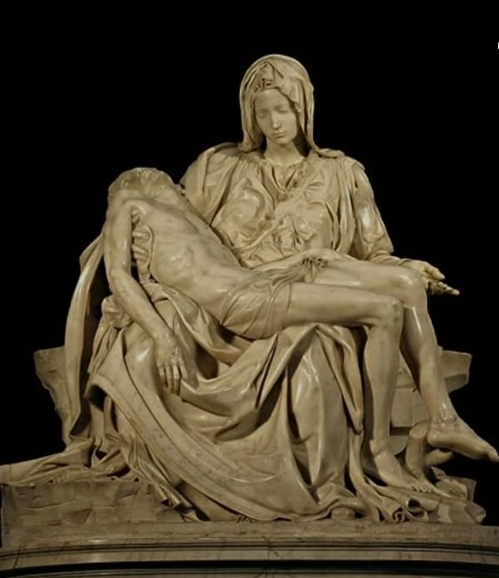
4 | Sketch drawing of sculptural works | 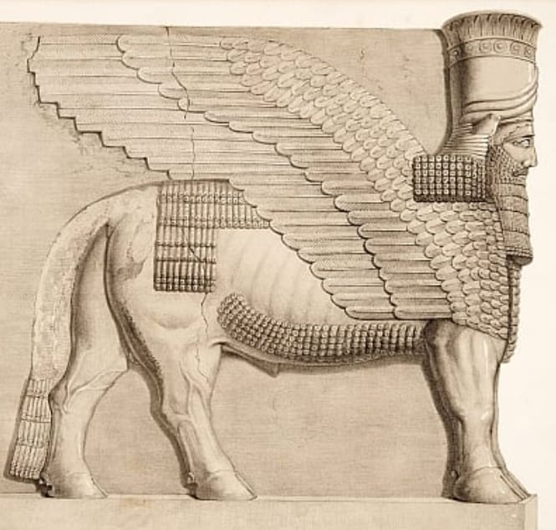
5 | Implementation of sculptural work | 1- The metal structure is made from a group of metal wires of different thicknesses. The metal structure represents the skeleton and is made of strong and sturdy wires so that the structure does not move during work, leading to clay falling and damaging the artwork. The parts of the metal structure are connected by thin wires and it is fixed. It has a structure, and these wires of various thicknesses can be purchased from construction equipment stores, where they are in the form of rolls or reels.  2- The metal structure is fixed from the middle to a wooden board using a metal support.  3- After that, the metal structure is moved as in the plans prepared for the sculptural work, and it is placed on the rotating sculpting table to facilitate moving the work and dealing with it from all sides.  4- Initially, small amounts of clay blocks are placed on the structure and fixed well around the structure until it takes on a geometric shape similar to the shape of the human body.
6 | Implementation of sculptural work | 1- The metal structure is made from a group of metal wires of different thicknesses. The metal structure represents the skeleton and is made of strong and sturdy wires so that the structure does not move during work, leading to clay falling and damaging the artwork. The parts of the metal structure are connected by thin wires and it is fixed. It has a structure, and these wires of various thicknesses can be purchased from construction equipment stores, where they are in the form of rolls or reels.  2- The metal structure is fixed from the middle to a wooden board using a metal support.  3- After that, the metal structure is moved as in the plans prepared for the sculptural work, and it is placed on the rotating sculpting table to facilitate moving the work and dealing with it from all sides.  4- Initially, small amounts of clay blocks are placed on the structure and fixed well around the structure until it takes on a geometric shape similar to the shape of the human body.
7 | Implementing geometric shapes | By deletion and addition, geometric shapes and details are determined in stages, using clay sculpting tools such as a knife and underground machines to achieve the shapes. As for fine details, special blades for deletion are used.  A flat piece of wood is also used when adding clay blocks to stabilize the clay by hitting it with the wooden piece until it is equal and takes the desired shape. Rectangular or oval pieces of plastic, the size of a fist, can be used to smooth the clay surface of the statue, remove the ripples, and level it until the statue takes its shape, so as to enter into the details. To add the initial details, special clay sculpting blades are used. They scrape off large quantities of the surface of the clay statue, and with this, the initial and basic details of the statue are sculpted.  After that, fine details are added using another type of clay sculpting blade.
8 | Implementing geometric shapes | By deletion and addition, geometric shapes and details are determined in stages, using clay sculpting tools such as a knife and underground machines to achieve the shapes. As for fine details, special blades for deletion are used.  A flat piece of wood is also used when adding clay blocks to stabilize the clay by hitting it with the wooden piece until it is equal and takes the desired shape. Rectangular or oval pieces of plastic, the size of a fist, can be used to smooth the clay surface of the statue, remove the ripples, and level it until the statue takes its shape, so as to enter into the details. To add the initial details, special clay sculpting blades are used. They scrape off large quantities of the surface of the clay statue, and with this, the initial and basic details of the statue are sculpted. After that, fine details are added using another type of clay sculpting blade.
9 | Monthly exam
10 | Implementing prominent shapes | History of relief sculpture  The art of relief sculpture was discovered since ancient times, and its first appearance was on the walls of caves. Then the Sumerians, Babylonians, ancient Egyptians, and Assyrians added inscriptions to the surfaces of stone buildings. Relief sculpture also appeared in ancient Roman and Greek sculptures, and relief sculpture appeared all over the world. Especially in the temple in Thailand, and images of the elephant, lion, and horse in the capital of India. During the Middle Ages, the art of relief sculpture appeared in Roman churches in Europe, and with the advent of the Renaissance, sculptors wanted to combine high and low relief sculpture, by carving figures at high heights and backgrounds. In relief, artists were able to sculpt in relief on materials such as: clay, marble, and stone, and the art of relief sculpture continues to this day.  1- Definition of relief sculpture: It is a technique in which a sculpture is engraved on a mostly flat surface. The engraving may be done on stone, wood, marble, clay, bronze, or any other material, and the carved element remains connected to the background and is prominent, so the shapes are deeply carved and may be high or may be Low and may be medium, and it is three-dimensional as it is viewed from all angles. The art of relief sculpture is used to describe a historical or religious story. Relief sculpture is considered one of the oldest forms of art, as the Sumerians began with it and spread to all parts of the world. Relief sculpture is divided based on the depth Engraving
11 | Implementing animal shapes | 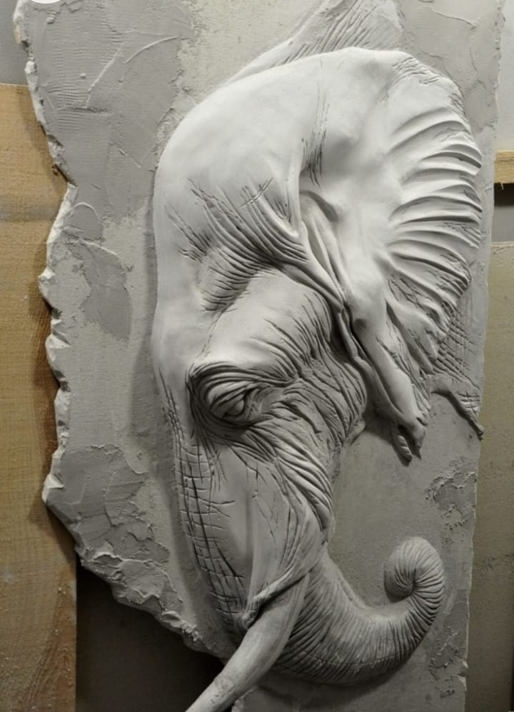
12 | Implementing animal shapes | 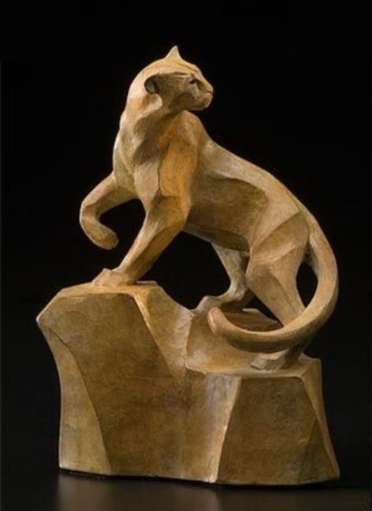
13 | Implementing floral shapes | 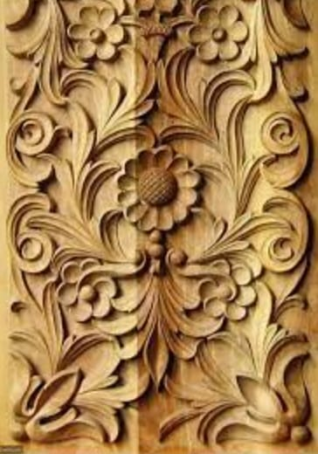
14 | Implementing floral shapes | 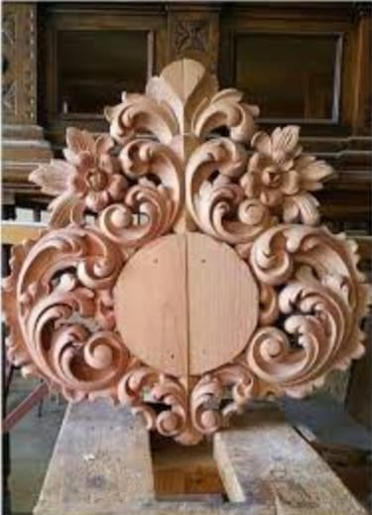
15 | First semester exam
16 | Implementing sculptural three-dimensional shapes | It is teaching the student the mechanism of building the metal structure to make the clay model through preliminary plans and learning the skills of the infrastructure work by achieving the desired shape. It consists of steps for making the infrastructure model, including preparing the metal structure, preparing the good clay, and starting the process of adding clay to the structure and distributing it according to the shape, in addition to distributing the butterflies. Carrying the clay with wires and preparing the necessary tools for sculpting, whether metal or wooden tools. Calling upon the sculptor, interacting with the professor, and adhering to his directions until the completion of the sculptural work.
17 | Implementing sculptural three-dimensional shapes | 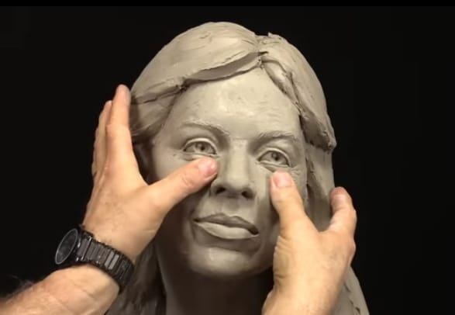
18 | Sculpting parts of the face | It is to teach the student the mechanism of building the metal structure to make clay botrytis through preliminary plans and learning the skills of subterranean work by achieving the desired shape. It consists of steps for making botrytis infrastructure, including preparing the metal structure, preparing good clay, and starting the process of adding clay to the structure and distributing it according to the shape, in addition to distributing the butterflies. Carrying the clay with wires and preparing the necessary tools for sculpting, whether metal or wooden tools. Calling upon the sculptor, interacting with the professor, and adhering to his directions until the completion of the sculptural work.
19 | Sculpting parts of the face | 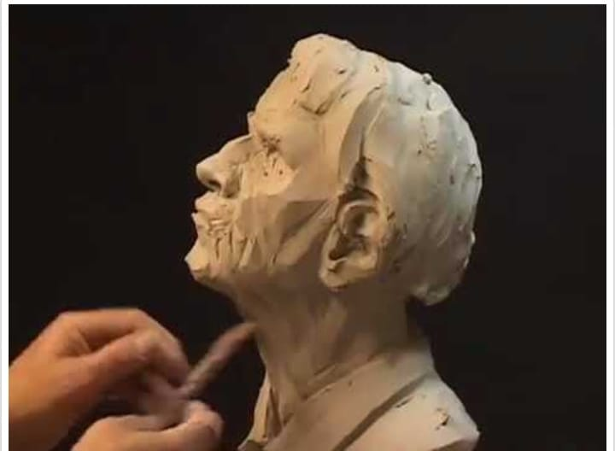
20 | Sculpting parts of the human body | It is to teach the student the mechanism of building the metal structure to make the clay model through preliminary plans and learning the skills of the underground work by achieving the desired shape. It consists of steps for making the basic statue of the human body, from preparing the metal structure, preparing the good clay, and starting the process of adding the clay to the structure and distributing it according to the shape, in addition to... Distributing butterflies carrying clay with wires and preparing the necessary tools for sculpting, whether metal or wooden tools. Calling the sculpting teacher and interacting with the professor and adhering to his directions until the completion of the sculptural work.
21 | Sculpting parts of the human body | 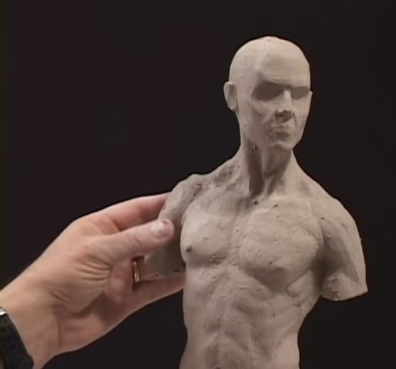
22 | Sculpting parts of the human body | 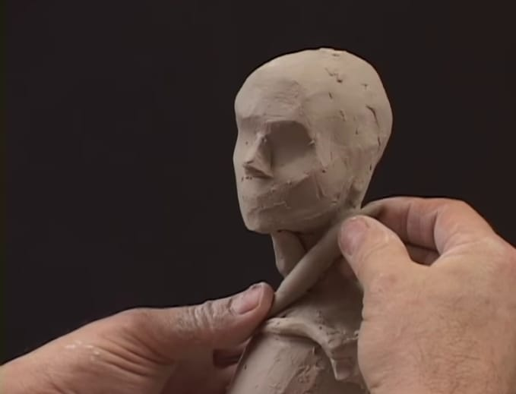
23 | Monthly exam
24 | Implementation of an anthropomorphic sculpture | 1- The metal structure is made from a group of metal wires of different thicknesses. The metal structure represents the skeleton and is made of strong and sturdy wires so that the structure does not move during work, leading to clay falling and damaging the artwork. The parts of the metal structure are connected by thin wires and it is fixed. It has a structure, and these wires of various thicknesses can be purchased from stores, where they are in the form of rolls or reels.  2- The metal structure is fixed from the middle to a wooden board using a metal support
25 | Implementation of an anthropomorphic sculpture | 3- After that, the metal structure is moved as in the plans prepared for the sculptural work, and it is placed on the rotating sculpting table to facilitate moving the work and dealing with it from all sides.  4- Initially, small amounts of clay blocks are placed on the structure and fixed well around the structure until it takes a three-dimensional shape close to the shape of the human body or any other shape.
26 | Implementation of an anthropomorphic sculpture | Teaching the student a building mechanism through drawings, starting the process of adding clay to the structure, distributing it according to the shape, and preparing the necessary tools for sculpting, whether metal or wooden machines. Calling the sculptor to interact with the professor and adhering to his directions until the completion of the sculptural work.
27 | Sculpture murals | 1- The metal structure is made from a group of nails and metal wires of different thicknesses. The structure represents the structure’s network and is made of strong and durable wires so that the structure does not move during work, leading to clay falling and damaging the artwork. The parts of the metal structure are connected using light-thick wires. The structure is attached to it, and these wires of various thicknesses can be purchased from stores, where they are in the form of rolls or reels.  2- The metal structure is fixed on a wooden board using a support.  3- After that, the mural is moved as in the plans prepared for the sculptural work, and it is placed on the sculpting table to make it easier to install the work and deal with it from all sides, creating a relief sculpture.  4- In the beginning, small amounts of clay blocks are placed on the structure and fixed well around the structure until it takes on a prominent sculptural shape that is close to the shape of the intended sculpture or any other shape.
28 | Sculpture murals | 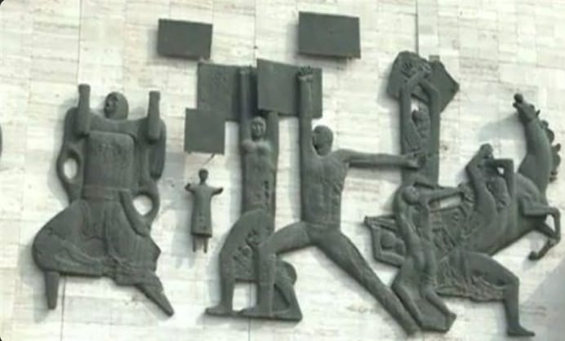
29 | Sculpture murals | 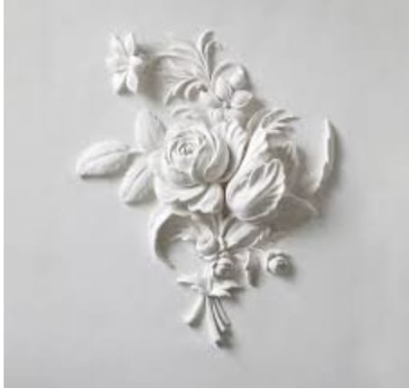
30 | Semester exam

Signature of the subject: Dr.muhamad alwan khadim

