المادة الدراسية (اللغة الانكليزية) لطلاب المرحلة الثانية في كلية الفنون الجميلة للعام الدراسي 2023-2024
م.د اسماعيل حسن عبيد الشامي

- Getting to know you/ social expressions

How are you? Fine/Very well thanks/OK/Not bad Unacceptable: Very fine./Good(unless you are American)
Thank you. You’re welcome/It’s nothing./Not at all.
How do you do? How do you do?/Pleased to meet you./Nice to meet you.
Where do you come from? I’m from .....(country). Unacceptable: I come from my house.
I’ve just got married. Congratulations! Unacceptable: Me too! Oh, really! Etc.
Have you got a light? Here you are./Sorry, I don’t smoke.
Have a nice day! Same to you. / You too. Unacceptable: Same with you.
How long have you been living in this country? I have been living here for.... Unacceptable: I’ve been living here since.../I’m here for.../I have ...years living here.
Do you mind if I join you? Please do./ Of course not./Feel free./You are more than welcome./Sure./Go ahead./By all means.
Help yourself to a drink. That’s very kind of you./Thank you very much.

How’s it going? Fine/Very well thanks/OK/Not bad Unacceptable: Very fine./Good(unless you are American)
Pleased to meet you! Pleased to meet you too./How do you do?/Nice to meet you too.
Do you mind if I smoke? Not at all. /Feel free./By all means./Go ahead.
What have you been doing? I’ve been ......(verb in gerund).
I hope you have a good weekend. Same to you./Likewise./You too. Unacceptable: Same again.(In bars only)
I hope your sister gets the job. I hope so too.
When you see Peter say ‘hello’ from me. Yes, I will./ I shall do that.
What is your sister like? She’s tall/nice/kind/beautiful /ugly etc. Unacceptable: She likes .......
Do you need any help with that bag? That’s very kind of you. No. I can manage. /No. That won't be necessary.
Let me pay for a taxi home for you. That’s very kind of you./How kind./How nice./That won’t be necessary.
My great grandfather passed away this morning. I’m very sorry to hear it./May I offer you my condolences. Unacceptable: Sorry!

- Present simple tense/ affirmative form

When we use the present simple in its affirmative form, we start with the subject followed by the base form of the verb. In the third person singular, we add an –s. For example: — “I work on important projects.” = The sentence is in the present simple affirmative, so we use the base form of the verb to work (work).

Affirmative: He is as good as I am. Negative: I am not better than he is. Affirmative: He is the best student. Negative: No other student is as good as he.

Examples of Affirmative Sentences
- I have a puppy.
- My brother bought fifty varieties of fighter fish.
- There is a three-storeyed house in the corner of the street.
- Manu is the new manager.
- Tokyo is the capital of Japan.
- My phone has two displays.
- The teacher gave us our marksheets.

- Making conversations/countries and their adjectives
Reading strategies are teaching methods and activities that teachers and parents can use with their children to help develop language and reading skills. Strategies that improve decoding and reading comprehension skills benefit every student, but are essential for beginning readers, struggling readers, and English Language Learners.

There are many different reading strategies that you can apply to your reading sessions in the classroom. To improve reading comprehension, teachers can introduce the 7 cognitive reading strategies for effective readers. These focus on encouraging skills such as activating, inferring, monitoring-clarifying, questioning, summarising, and visualising. Read more about strategies of reading with Twinkl below.

Keep a sharp eye on visual clues:Does the book or text include any images that represent the text? Readers use the clues from the text to create a picture in their head. They use all their senses and imagination to create their mental image. Encourage your students to take a look at any visual clues in the text to see if they give you any clues that will help them to decode the text.
Sound it out: If your children are struggling with a particular word, break it down phonetically and say each sound seperately aloud. This should help them piece together tricky words and understand how sounds interact. (Remember to look for diagraphs and trigraphs as you read.)
Summarising: Summarising allows the reader to digest small snippets of information in a simple structure. This means that they’re able to understand the basics of the text without needing to read it all. Using summaries as a reading strategy can help children identify key information and phrases in a text.
Ask questions:Readers should learn to ask and answer questions to clarify meaning and ensure they understand what they have read. To help this reading strategy, encourage children to ask questions before, during and after reading.
Make predictions:Readers use written and visual clues from the text as well as their own person experiences to make predictions about what might happen before, during and after reading. Using this strategy in reading helps children become more confident in understanding key features of a story and piece together clues in writing.

- Past tense/ regular and irregular verbs.

Past simple
We often add -ed to verbs (regular verbs) to make the past simple.
- We often watch a film on Saturday. ⇒ We watched a film last Saturday.
- I live in Barcelona. ⇒ I lived in Barcelona in the 90s.
Spelling of regular verbs
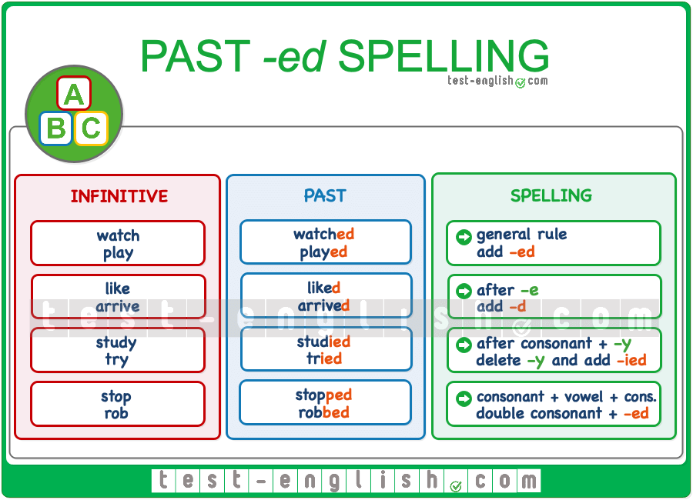

When do we double the consonant?
We double the consonant when the verb ends in consonant + vowel + consonant. This is always true when the verb is one syllable.
- stop ⇒ stopped, plan ⇒ planned, shop ⇒ shopped, rob ⇒ robbed.
When the verb is two syllables, we only double the consonant when the STRESS is in the last syllable.
- reFER ⇒ referred, preFER ⇒ preferred, reGRET ⇒ regretted
But we do NOT double the consonant when the STRESS is NOT in the last syllable.
- VIsit ⇒ visited, ANswer ⇒ answered.

- Present simple/ question and negative
Simple Present Tense Interrogative Negative Sentences
- Do I not go to school?
- Do we not dance in the pub?
- Do they not worship the cows?
- Do you not browse the internet?
- Does he not develop Android Apps?
- Does she not use Instagram?
- Does it not rain during the rainy season?
- Does Ashfaq not grow crops?

Negative questions
When there is no modal verb or be, we use auxiliary verb do + n't (don't, do not, doesn't, does not, didn't): Why didn't you ask Linda? What don't you understand? Won't we able to see the film?

- Dictations/ adding ed, es, ing
What is the rule for adding ing and ed?
If a vowel is followed by two consonants, just add -ed. Rule 2: If you have a v-c-e pattern, drop the silent e and add -ed. Rule 3: If a vowel is followed by one consonant, you must double the last consonant letter and add -ed. The suffix -ing makes 1 sound.

For one-syllable words that end in consonant-vowel-consonant (except x), double the last letter and add -ed. (Note: Never double final x.) Rule 5: For most other words (including words that end in x), simply add -ed with no changes.

When a root ends in y, change the y to i when adding a suffix (easy + est = easiest; happy + ness = happiness). Exceptions: Keep the y if a vowel comes before it (play + er = player; joy + ful = joyful). Keep the y if adding the suffix -ing (cry + ing = crying; study + ing = studying).
What is the difference between Ing and Ed? Ing is called a gerund whereas ed is the formative element or the termination that indicates past tense or the imperfect tense. ing is used to indicate or express an action that takes place at the time of speaking.

- Let’s go shopping/ much, many

Much, many with a noun
We use much with singular uncountable nouns and many with plural nouns:
[talking about money]
I haven’t got much change. I’ve only got a ten euro note.
Are there many campsites near you?
Questions and negatives
We usually use much and many with questions (?) and negatives (−):
Is there much unemployment in that area?
How many eggs are in this cake?
Do you think many people will come?
It was pouring with rain but there wasn’t much wind.
There aren’t many women priests.
Affirmatives
In affirmative clauses we sometimes use much and many in more formal styles:
There is much concern about drug addiction in the US.
He had heard many stories about Yanto and he knew he was trouble.
In informal styles, we prefer to use lots of or a lot of:
I went shopping and spent a lot of money.
Not: I went shopping and spent much money.
See also:
- Lots, a lot, plenty
Much of, many of
When we use much or many before articles (a/an, the), demonstratives (this, that), possessives (my, your) or pronouns (him, them), we need to use of:
How much of this book is fact and how much is fiction?
Claude, the seventeenth-century French painter, spent much of his life in Italy.
Unfortunately, not many of the photographers were there.
How many of them can dance, sing and act?
This much, that much
Spoken English:
When we are talking to someone face-to-face, we can use this much and that much with a hand gesture to indicate quantity:
[the speaker indicates a small amount with his fingers]
I only had that much cake.

- Present continuous tense/ affirmative, question, and negative
Introduction:
In the present continuous tense, negative forms are made using NOT, and question forms are made by changing the word order of the sentence. This page explains the rules.
1. Forming a negative
Negatives in the present continuous are formed by adding not or n't after the verb BE:
Positive sentence Negative sentence Contracted negative
I am eating. I am not eating. I'm not eating.
You are working. You are not working. You aren't working.
He is driving. He is not driving. He isn't driving.
She is teaching. She is not teaching. She isn't teaching.
It is raining. It is not raining. It isn't raining.
We are reading. We are not reading. We aren't reading.
They are writing. They are not writing. They aren't writing.
2. Forming a question
Yes/no questions are created by moving the verb BE to the beginning of the sentence. WH-questions are formed by moving the verb BE, and then adding the WH- word. Here are the rules:
Statement Yes/no question WH- question
I am eating. Am I eating? What am I eating?
You are crying. Are you crying? Why are you crying?
He is going. Is he going? Where is he going?
She is arriving. Is she arriving? When is she arriving?
It is sleeping. Is it sleeping? Why is it sleeping?
We are leaving. Are we leaving? When are we leaving?
They are fighting. Are they fighting? Why are they fighting?
When you are sure that you understand the lesson, you can continue with the exercises.
- What do you want to do/ future forms
How do you use future forms?
We have different ways of talking about the future. We often use going to (+ infinitive), the present continuous (to be + -ing) or will (+ infinitive). The structure we use depends on the function of what we want to say, whether we are talking about arrangements, plans, predictions, etc..
Will future form examples?
The Simple Future Tense
- I will meet him later (I'll ..)
- You will come (you'll..)
- It will rain tomorrow (it'll)
- She will be late (she'll..)
- He will help us later (he'll..)
- We will get married in September (we'll)
- They will cook dinner (they'll..)

What are the 10 examples of will?
How do you talk about future plans?
We use the present continuous tense to talk about things that we are presently considering.
- “I'm thinking of going to …”
- “We're planning to go to…”
- “He's hoping to go to…”
- “I'm toying with / playing with the idea of…”
- “We've decided to go to Greece.”
- “We've settled on Spain, after all.”

- Synonymous and antonymous/ dictation
A synonym is a word, morpheme, or phrase that means exactly or nearly the same as another word, morpheme, or phrase in a given language. For example, in the English language, the words begin, start, commence, and initiate are all synonyms of one another: they are synonymous. The standard test for synonymy is substitution: one form can be replaced by another in a sentence without changing its meaning. Words are considered synonymous in only one particular sense: for example, long and extended in the context long time or extended time are synonymous, but long cannot be used in the phrase extended family. Synonyms with exactly the same meaning share a seme or denotational sememe, whereas those with inexactly similar meanings share a broader denotational or connotational sememe and thus overlap within a semantic field. The former are sometimes called cognitive synonyms and the latter, near-synonyms, plesionyms or poecilonyms
Synonyms can be any part of speech, as long as both words belong to the same part of speech. Examples:
- noun: drink and beverage
- verb: buy and purchase
- adjective: big and large
- adverb: quickly and speedily
- preposition: on and upon
Synonyms are defined with respect to certain senses of words: pupil as the aperture in the iris of the eye is not synonymous with student. Similarly, he expired means the same as he died, yet my passport has expired cannot be replaced by my passport has died

